Germantown High School
Bell Schedule
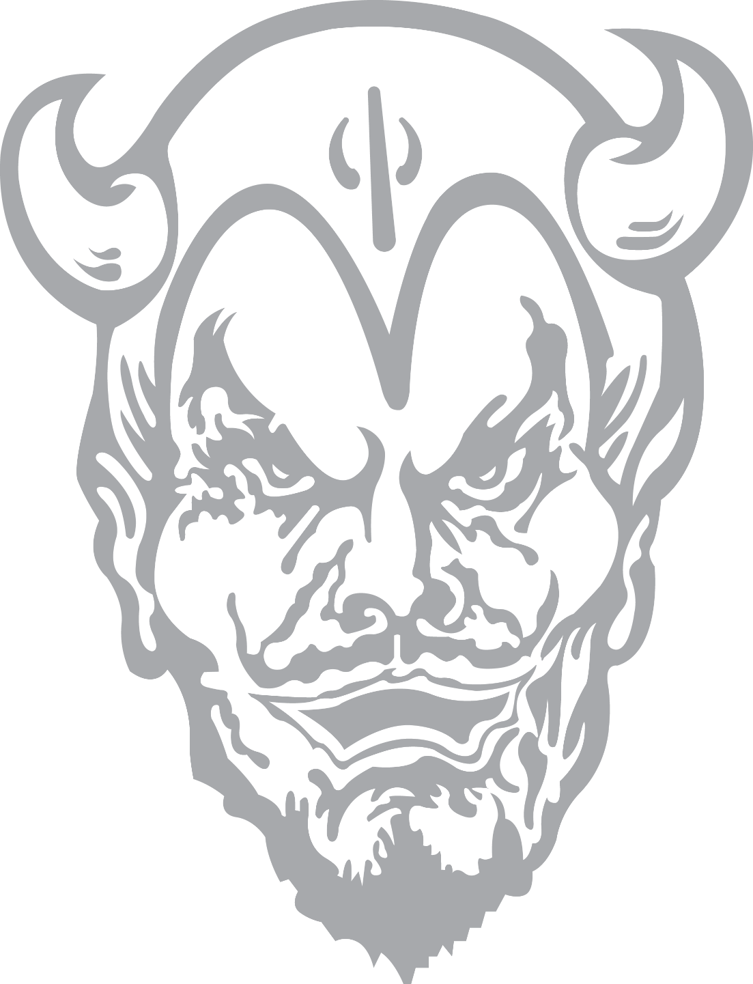
2021-2022

1st 7:15-8:02
2nd 8:07-8:52
3rd 8:57-9:42
Intervention 9:43-10:14
4th 10:19-11:04
5th 11:09-12:35
A Lunch (MA, S, and ROTC) 11:09-11:28
B Lunch (M and V) 11:29-11:50
C Lunch (B, C, and PE) 11:52-12:13
D Lunch (A, Prod., and Band) 12:14-12:35
6th 12:40-1:25
7th 1:30-2:15

